Gatepass System – Requirements & Issues
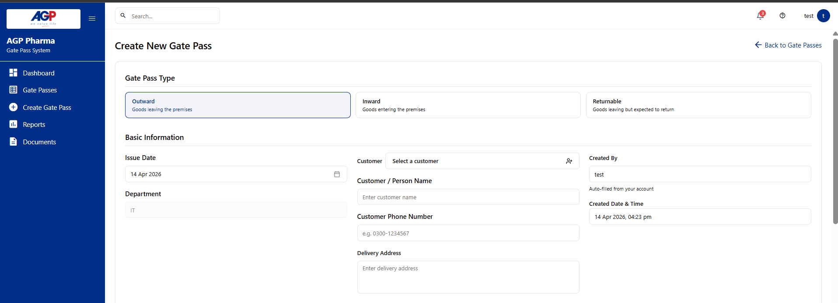
1. Initiator Screen
Gatepass Type
- When Outward Gatepass is selected, the user should see two options:
  - Returnable Gatepass
  - Non-Returnable Gatepass
Non-Returnable Gatepass – Form Fields (Sequence)
- Company
  - Only companies assigned to the user should be visible.
- Customer / Vendor / Employee
  - As already discussed earlier.
- Date
- Department
- Plant
  - Only assigned plants should be visible.
- Gate
  - Only gates assigned in the backend should appear.
Allow To
- A person name who carried out asset and material
Driver Details
- Driver Name (Optional)
Driver number and etc (optional)
Item Details
- Item Type: Asset / Material / Other
- Item Code
- Item Name
- UOM
- Quantity
  - Quantity should be fixed if Item Type = Asset
  - Quantity should be editable if Item Type = Material or Other
- Reason
Attached Documents
- Option to attach supporting documents.
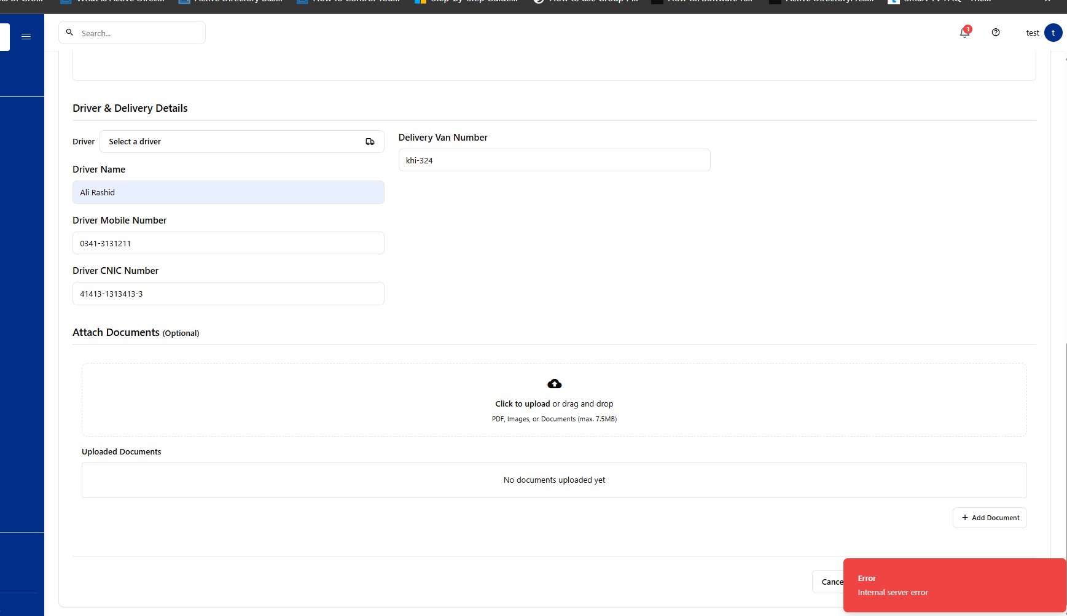
2. Returnable Gatepass
- All fields should be the same as Non-Returnable Gatepass.
- An additional field must be added:
  - Expected Return Date
Issue
- When saving or submitting a Returnable Gatepass, an Internal Server Error appears.
- This issue needs to be fixed urgently.

3. Field Layout Requirement
- All fields (including Driver and other optional details) should appear together at the top of the form.
- Optional fields should not be shown in separate sections.

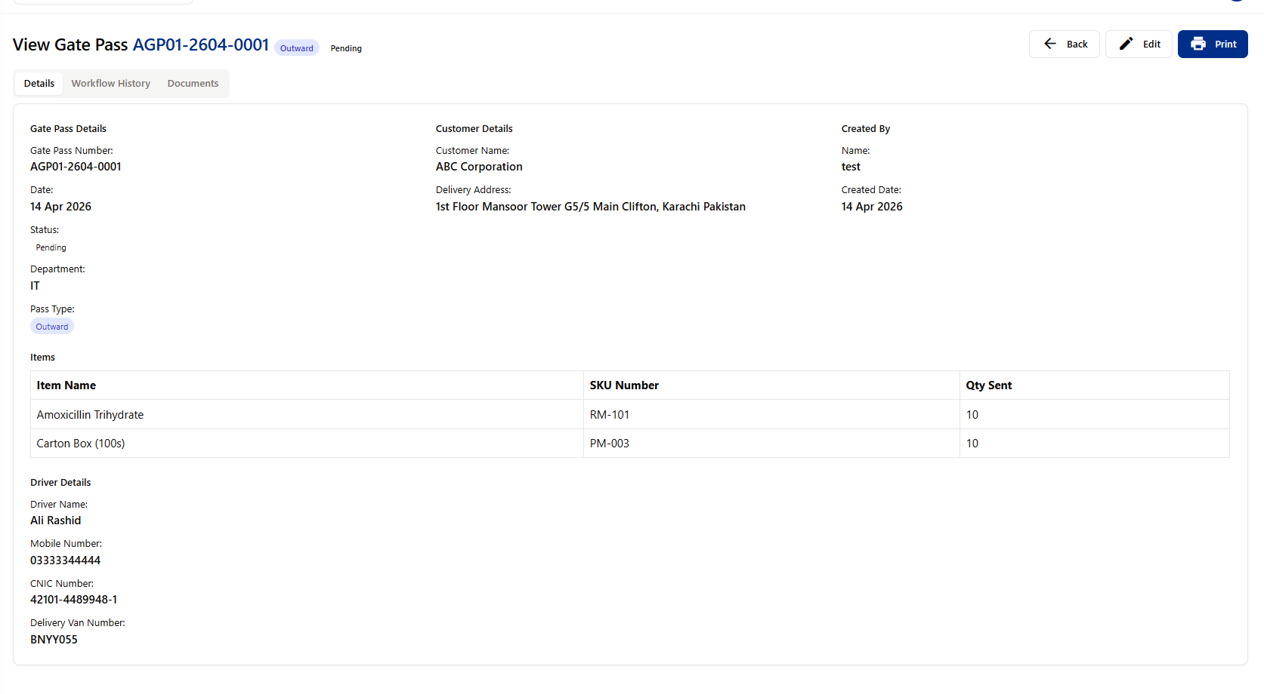

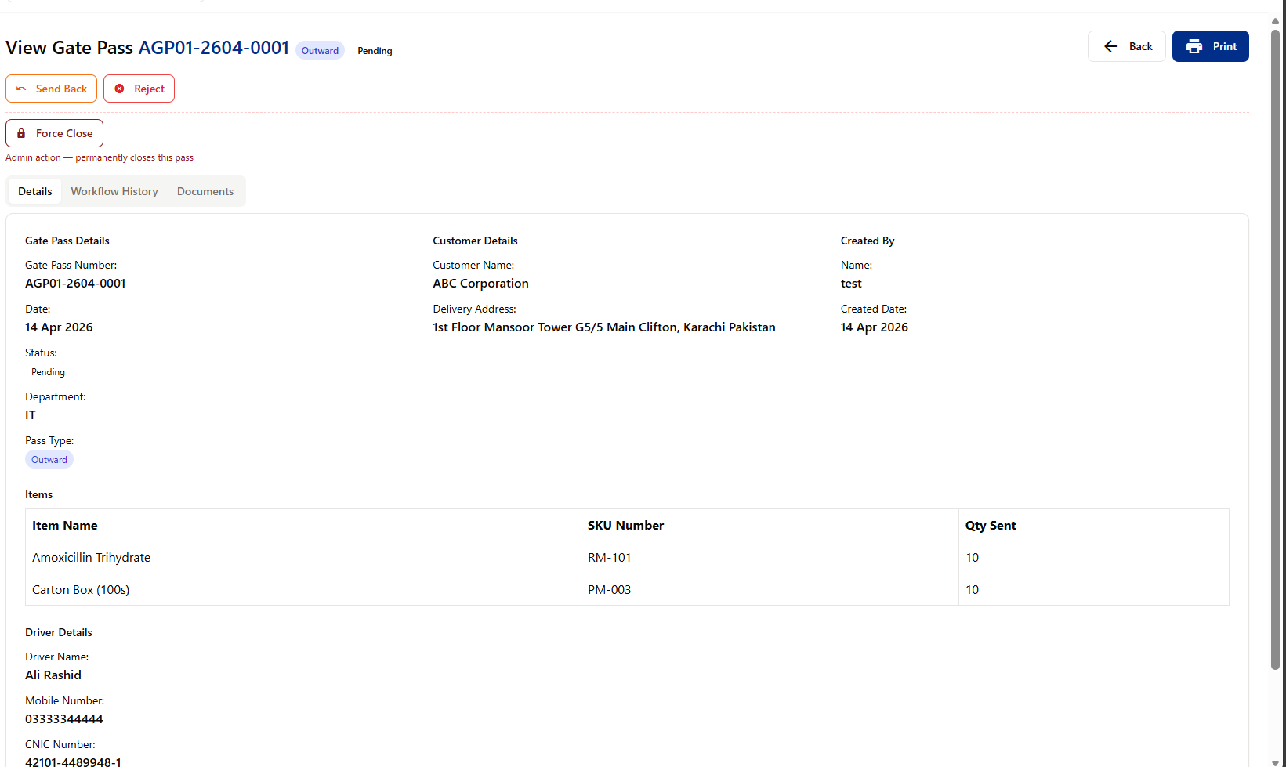

4. Approval Workflow Issues
Issue 1: Approver Issue
- A Non-Returnable Gatepass was created and submitted successfully.
- HOD sent the request back for correction.
- After correction and resubmission:
  - Approver does not see the Approve option.
  - Status still shows Sent Back / Rejected.
- This needs to be fixed.
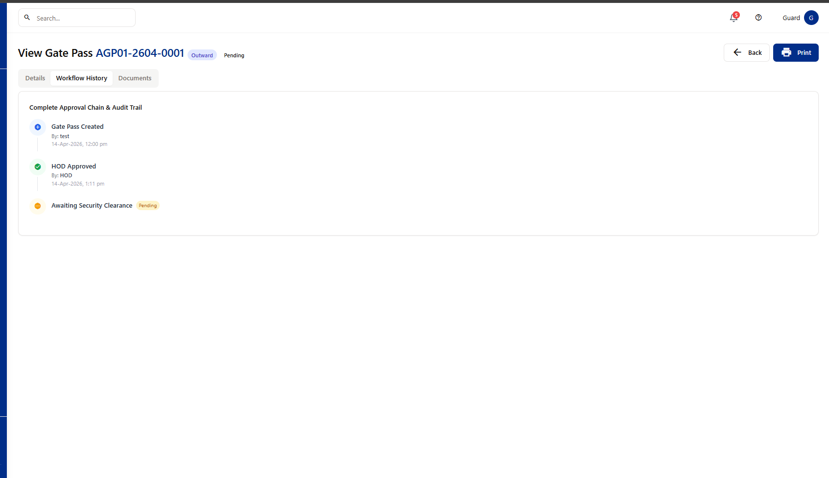

Issue 2: Security Role Issue
- Security user does not see any Approve or Allow option.
- Security should receive requests from all departments.
- There should not be a separate security role for IT.
- All department gatepasses must be visible to security.
5. Gatepass Numbering Format
Non-Returnable Gatepass
OutwardNonReturnable – CompanyCode – Department – Year – 0001
Example:
OWNR-AG01-IS-2026-0001
Returnable Gatepass
OutwardReturnable – CompanyCode – Department – Year – 0001
Example:
OWR-AG01-IS-2026-0001
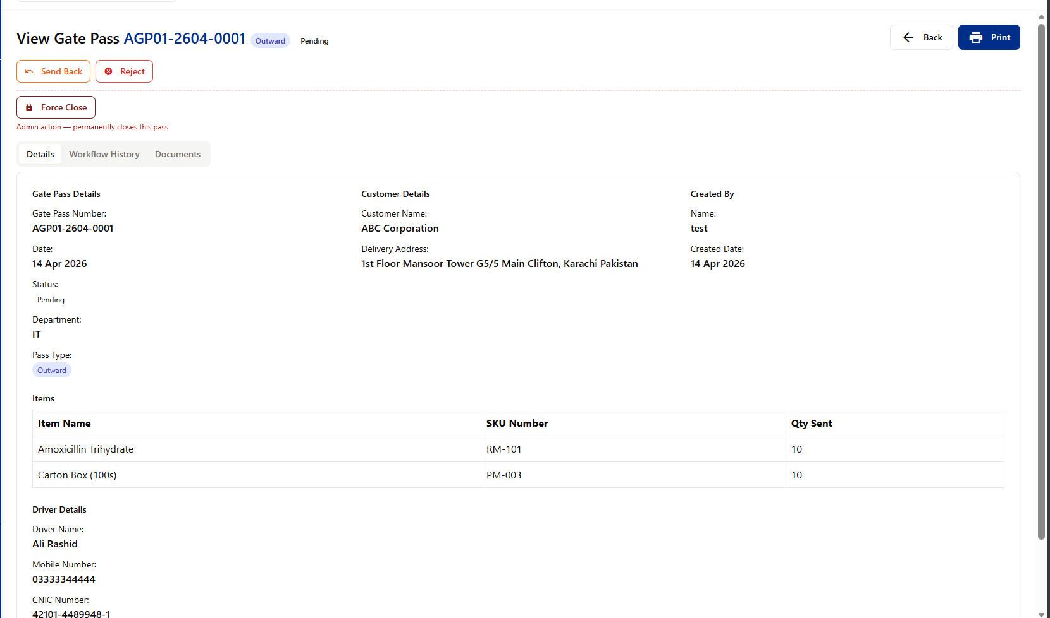

6. Approver Screen Requirements
- Approver screen must be properly designed.
- Driver details should be optional and displayed on the main form
- All fields visible during gatepass creation must also be visible to:
  - Approver
  - Security
- Allow To field:
  - Must be visible to Security
  - Security should be able to edit/change this field.
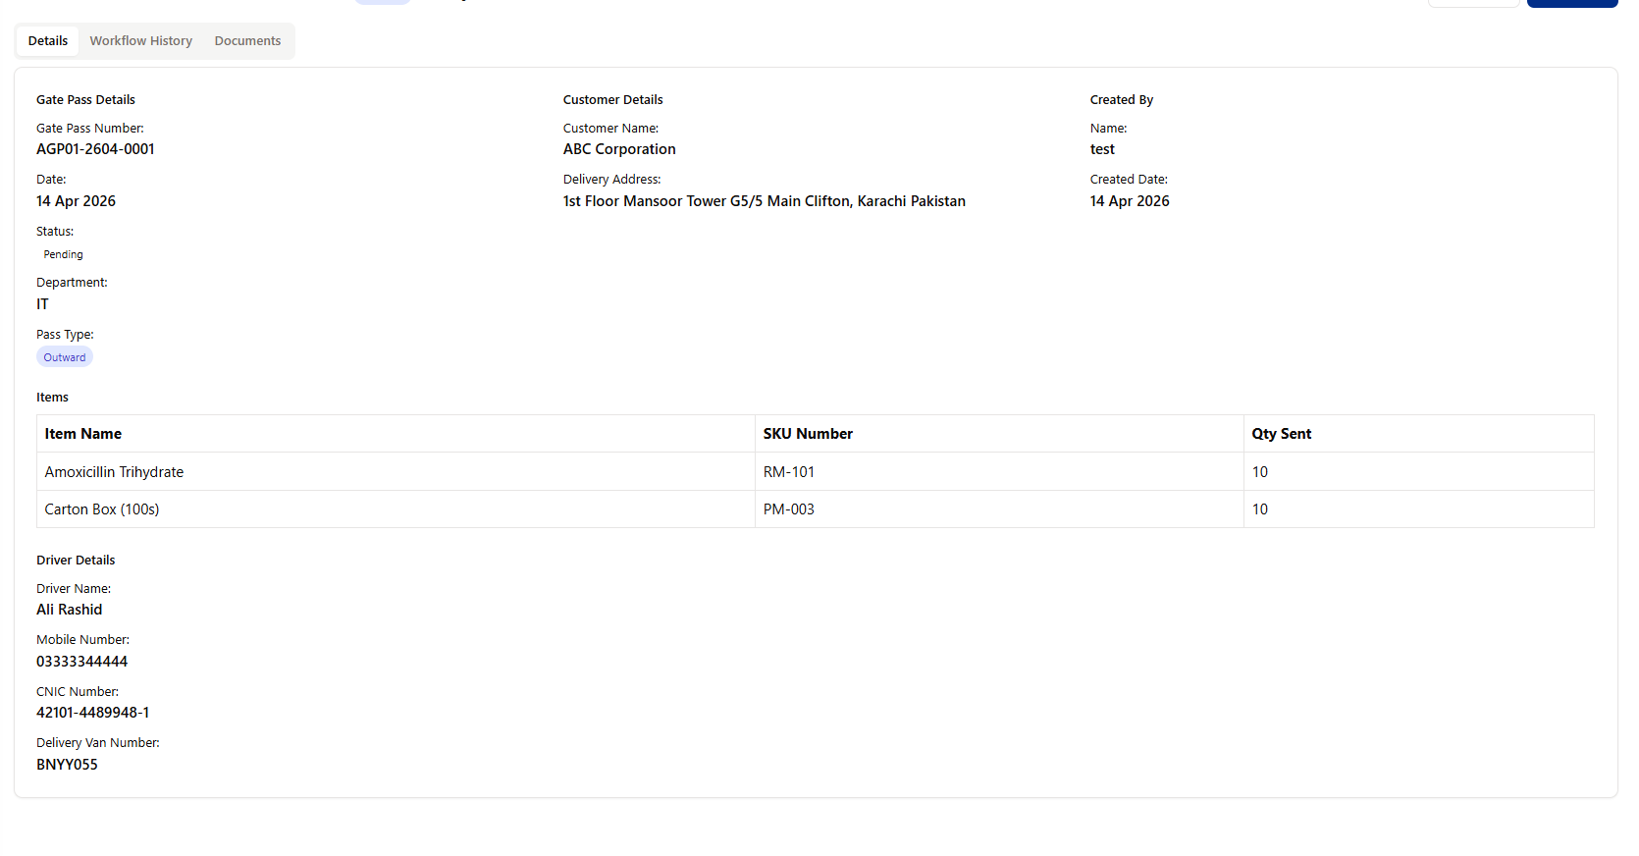

7. Print Options (Security Only)
- Print option should be available only to Security.
- Security should be able to print:
  - Before approval
    - Print should show “Not Approved” label.
  - After approval
    - Two copies should be printed:
      - Security Copy
      - Vendor / Customer / Employee Copy

8. Admin Panel
Register Employee Sequence
- Role* (Admin, Initiator, Approver, Security, Reports View Only)
- Company*
(Departments will be shown company-wise. Only the departments that exist within the selected company will be visible.)
Same logic as Division Category →
Example:
  - Department: Marketing
  - Division Category: Div A
  - Division: Gynae-A
Question:
How can we give an Initiator access to multiple companies?
(For example, the user should have access to all three companies.)
- Department*
- Division Category (Optional)
- Division (Optional)
- Employee Code*
- Full Name
- Email
- Username Field?
  - Will the username be defined here, or fetched automatically from Active Directory (AD)?
  - How will we determine whether this user should be a gate pass user or not?
  - Since multiple users may exist in AD, only the selected user should be able to create, approve, or security-approve gate passes.
- Password and Confirm Password?
- Passwords will always be from Active Directory (AD).
- If the password is changed in AD, the user should be required to log in again here using the new password.

Additional Question
- How will we assign a plant and gate to a user?
(For example, a specific user should only be able to create gate passes for a specific plant and a specific gate.)

Note
- If details are entered in the “Register Employee” form and the user tries to navigate to another tab, a prompt should appear:
“Do you want to save the changes? (Yes / No)”

